Getting Started

# Rules of the game

This game is a hybrid of cricket and hand cricket. To know more about hand cricket, visit <https://www.instructables.com/id/How-to-Play-Hand-Cricket/>

Whatever you show your opponent, enter its value. For example, showing an open palm to your opponent represents 5. Input 5 and not ‘open palm’.

The ultimate goal is simple: Score more than your opponent to win.

# OS Pre-requisites

To play this game, you need to have Python software installed. You can download the software from <https://www.python.org/downloads>.

**NOTE: THIS GAME IS CROSS-PLATFORM COMPATIBLE.**

Supported platforms:

* Microsoft Windows 7 or later
* Android API 24 or later (Apps are available on the Play Store)
* Mac OS X 10.6 or later
* Linux

Disk space: 32 MB (minimum), 256 MB or more (recommended)

# What’s this project?

This is a hybrid of cricket and the legacy hand cricket game – implemented in Python and supporting text files.

This project was built entirely on Python 3.7.4 and is compatible with all versions of Python 3.5 and newer.

The game can be played even without an internet connection.

Tournament mode is not yet included in this game. Customized tournaments can be created using individual team files. For such tournaments, at least 256 MB of disk space is recommended.

# Known bugs and vulnerabilities:

* A hack exists wherein a team may abruptly and deliberately close the application to avoid losing a match. This bug is not fixed since a more serious bug, in which unexpected crashes would lead to a loss irrespective of the position, would otherwise overshadow the possibility of victory.
* There is no provision for rain delay and abandoned matches here.

# Procedure

## Setting up a team

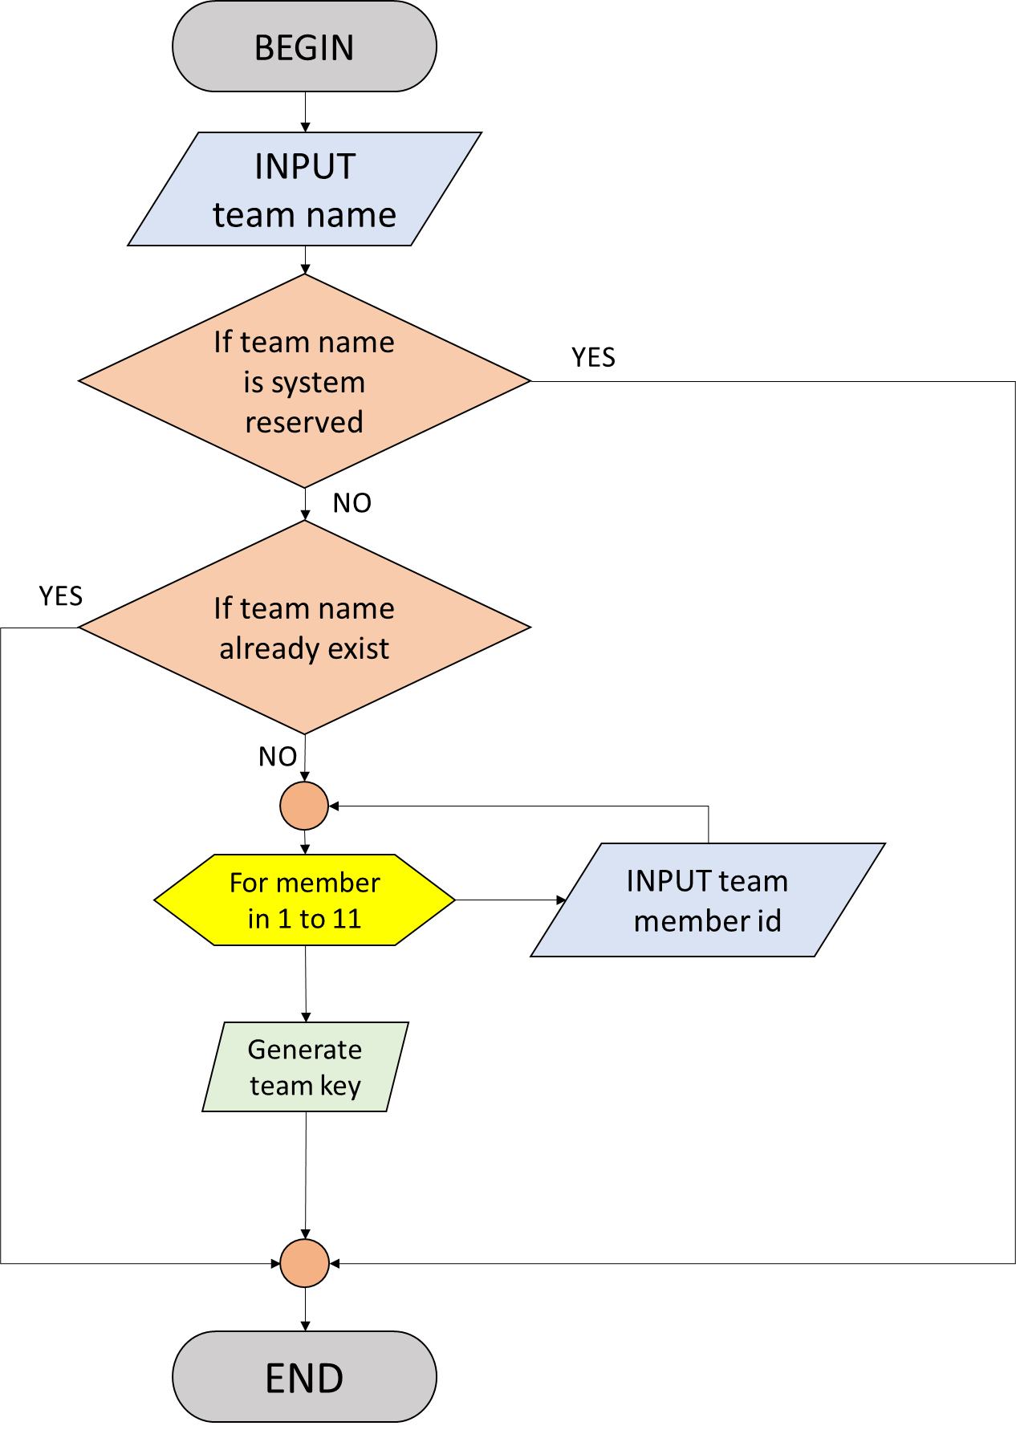

NOTE: The team can now choose its team key instead of a random string.

NOTE: If team name already exists, the program will terminate. Reopen the program and try again.

## Registering for a match

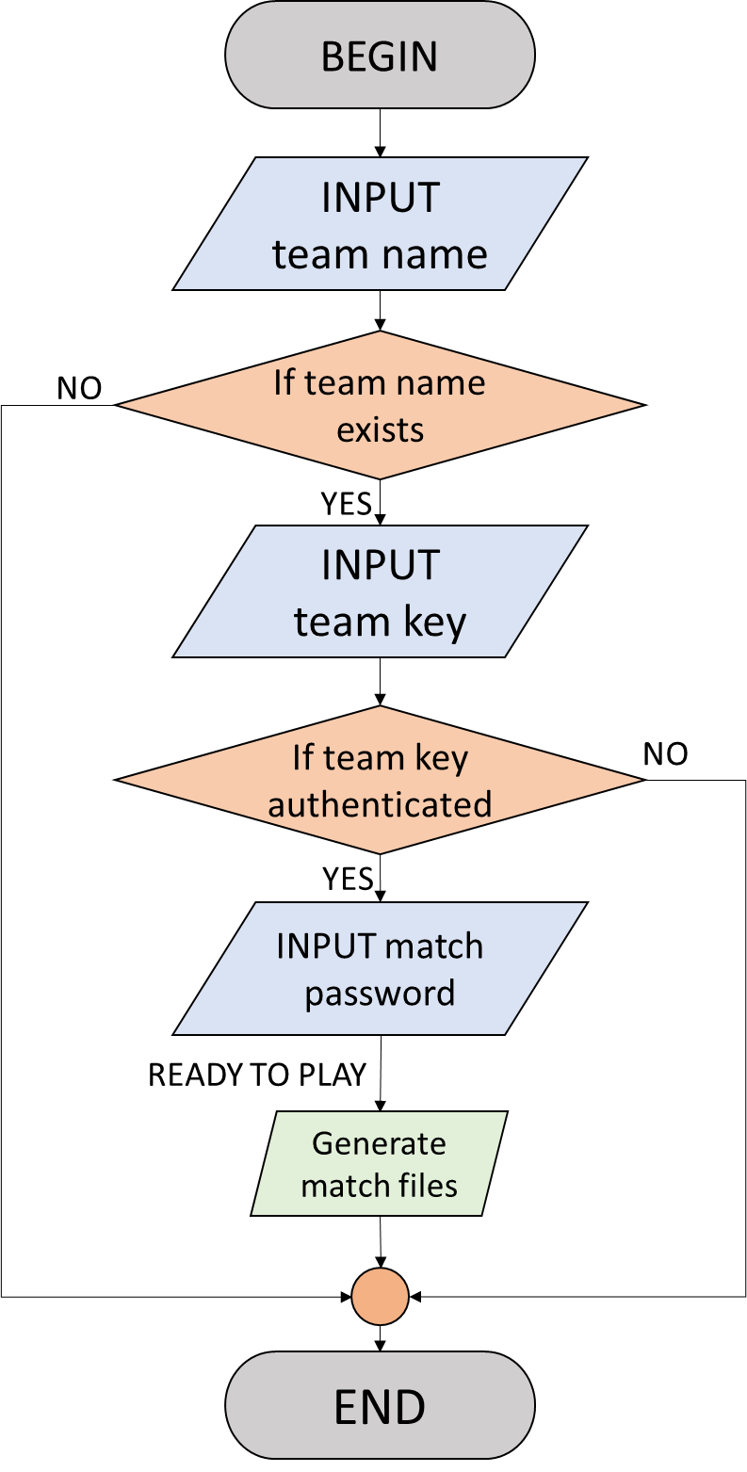

### Team pairings:

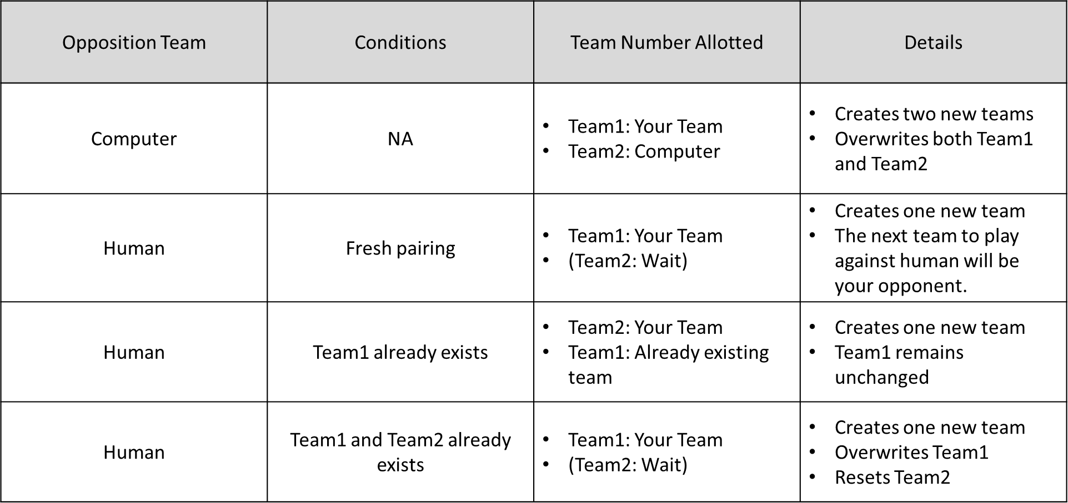

## Gameplay

### (Part – 1) Authenticating playing team

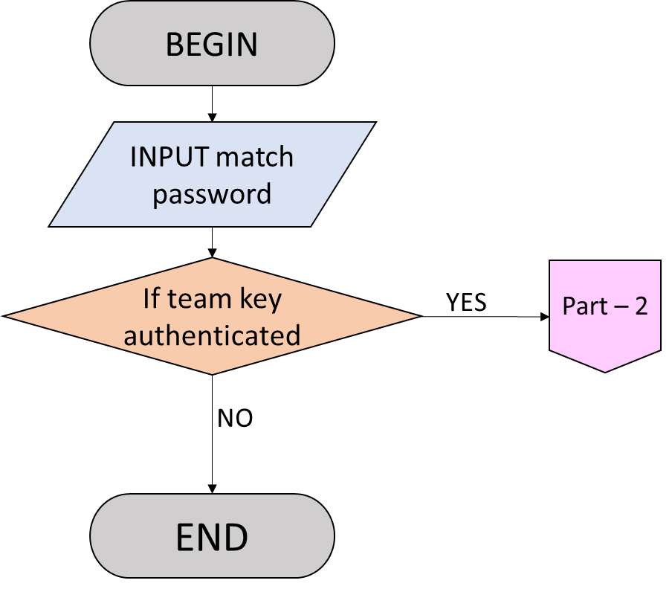

### (Part – 2) Deciding number of overs and wickets

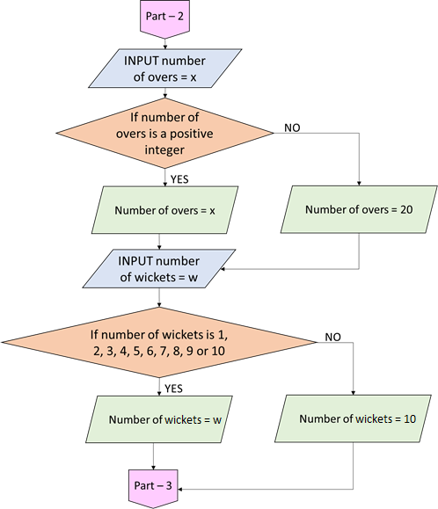

### Toss

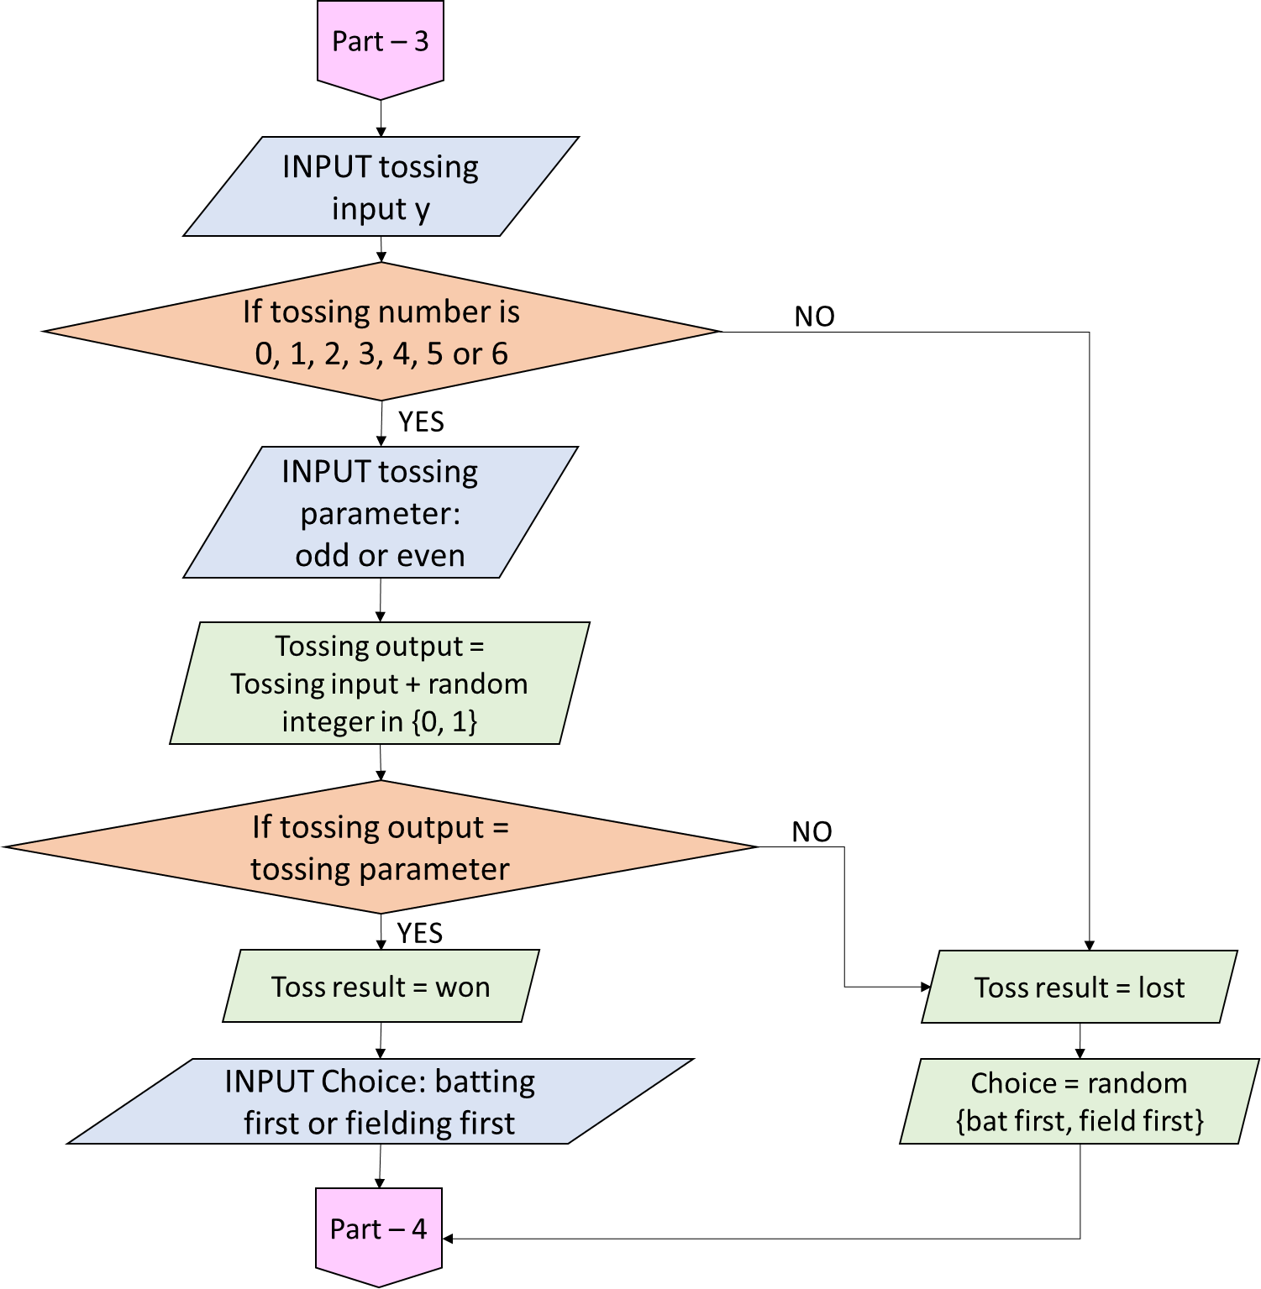

### Innings

#### Main function

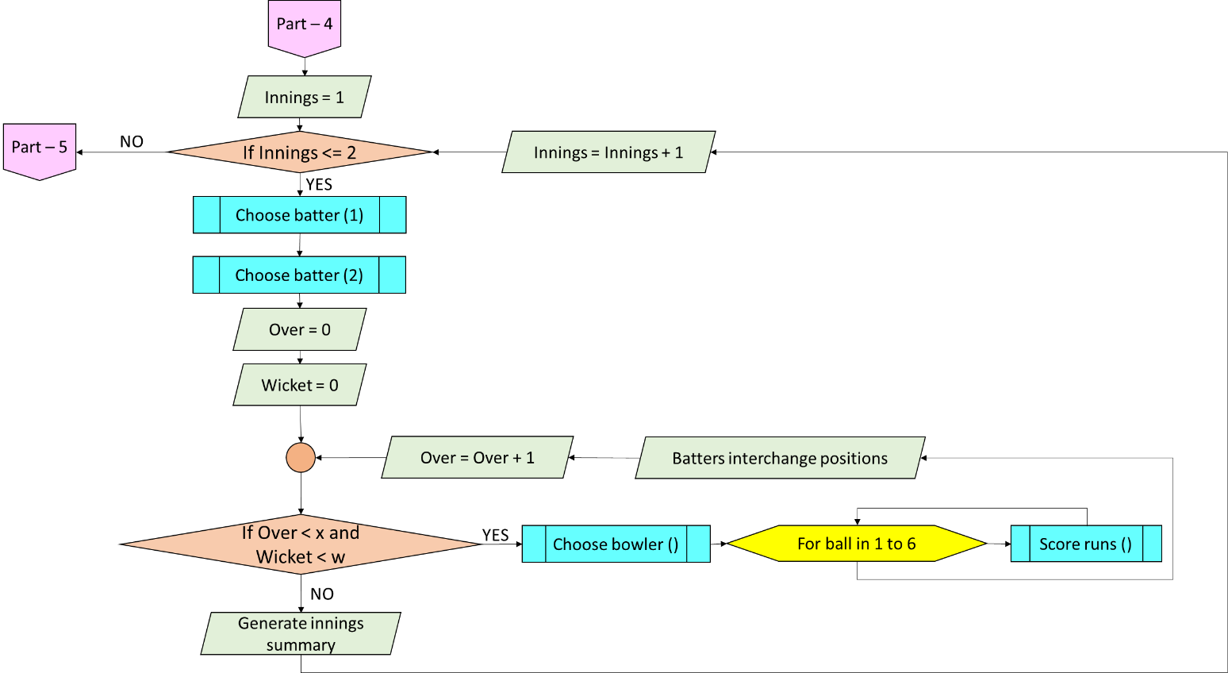

Here, x represents the total number of overs and w represents the total number of wickets.

Note that if all the wickets fall, the innings ends irrespective of whether the over was completed or not.

In the super over, only 1 over and 2 wickets per innings is permitted as per official rules.

#### Choose batter (n)

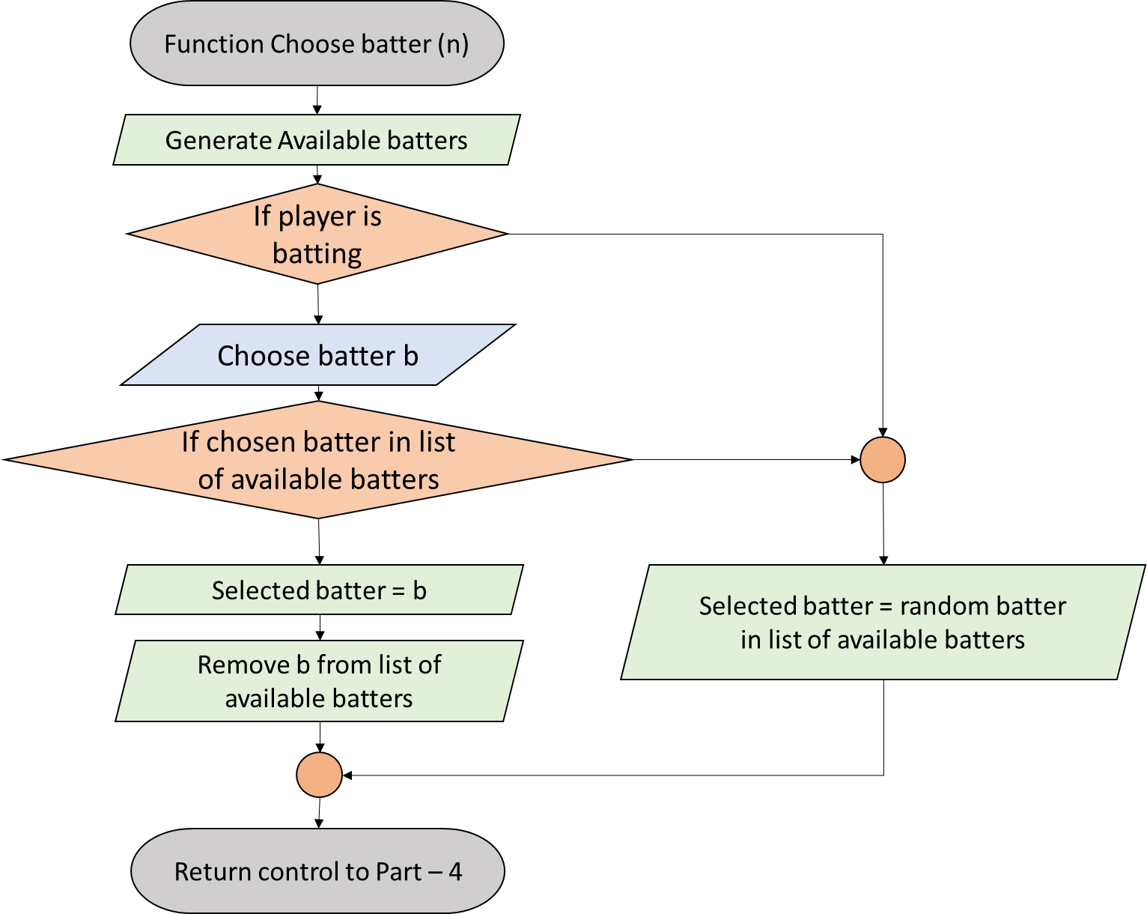

#### Choose bowler

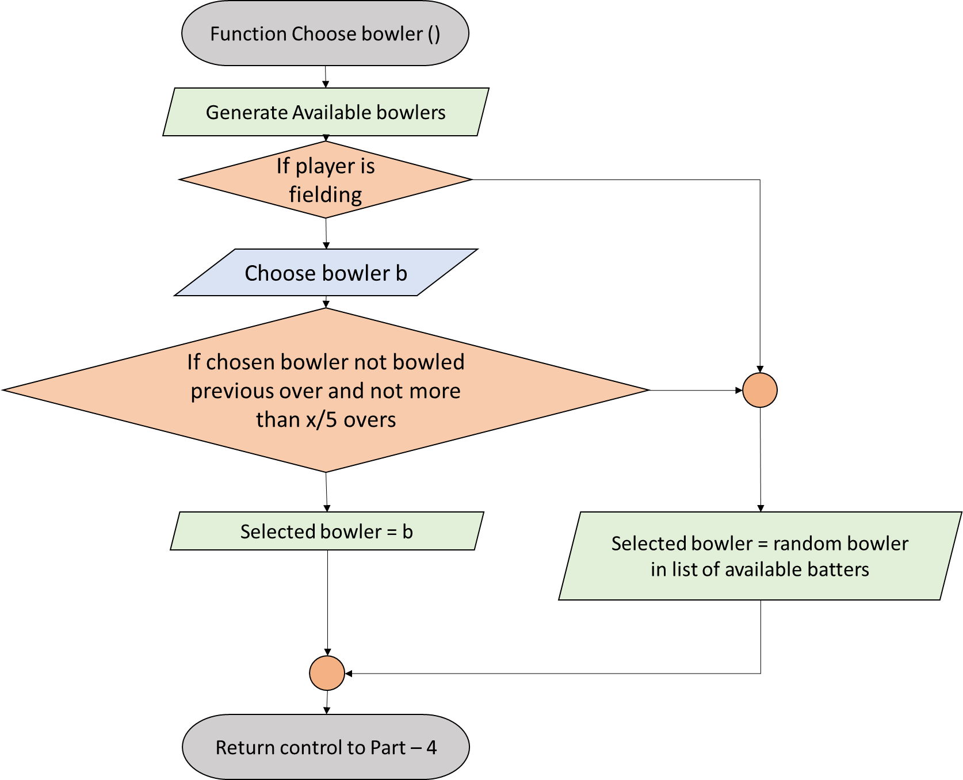

Here, x represents the total number of overs. The condition on x is implemented as per the official rules of cricket.

In the super over, only one bowler can bowl.

#### Score runs

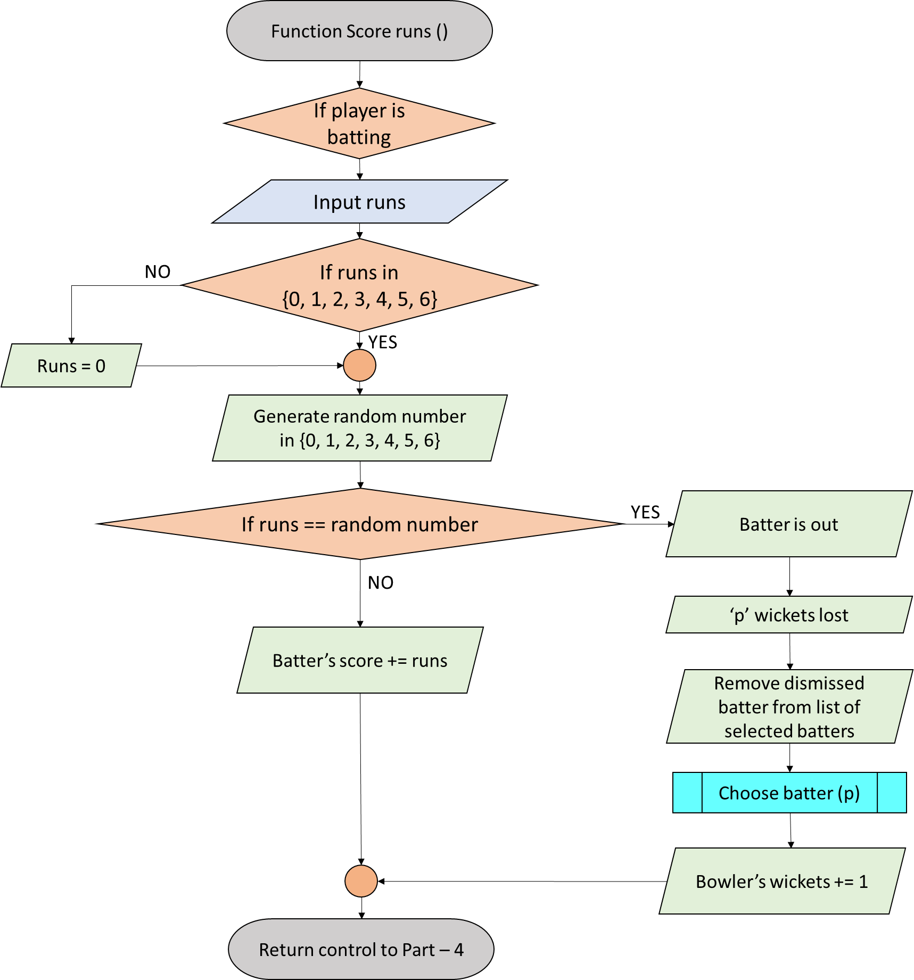

#### End of the match

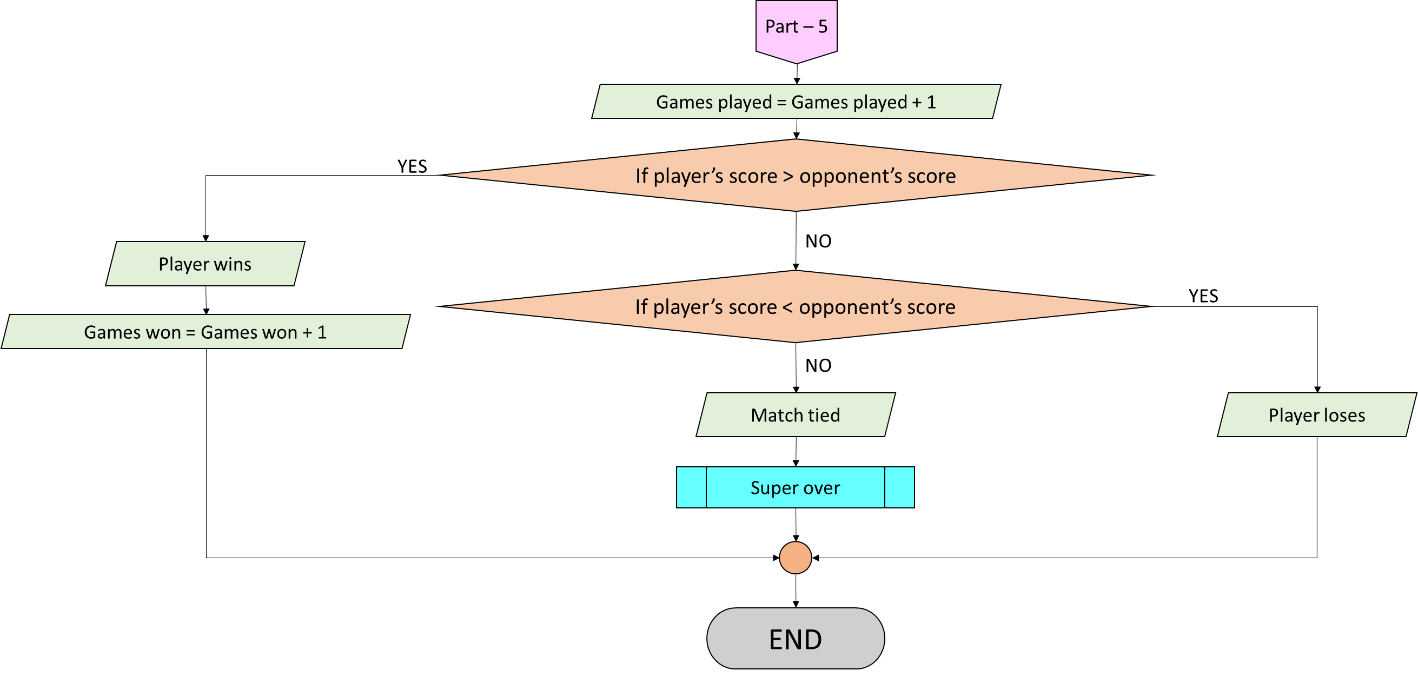

#### Super Over

The whole gameplay program is same, except for the following few changes:

* There is no toss. If the player batted first in the tied match, he/she will field first in the super over and vice versa.
* There is only one over per innings, as the name suggests.
* Each team has a maximum of two wickets.
* As per revision to the ICC rules following the 2019 World Cup Final which England won on boundary count, super over will be repeated if it is also tied, until there is a winner.
* In this super over component, the number of games played won’t change. There are also measures to protect this component from being misused.

#### Test Cricket

There are many significant differences between limited-overs cricket and test cricket. The differences implemented in this game include:

* Each team gets to play a maximum of two innings instead of one.
* There is no fixed limit to the number of overs played.
* You can end your innings anytime, unless you are chasing down a target.
* Follow-on is permitted if the team batting first leads by at least 75 runs.

# Gameplay instructions

## Setting up a team

* Open the python file ‘setupateam.py’.
* Enter a team name of your choice. Before you proceed, please ensure that your team’s name is not present in the same folder. All team data is stored in ‘teams’ folder. For example, if a team name ‘2’ is present, the target file is ‘teams/team2.json’. Therefore, if you want to name your team as ‘2’, the file ‘team2.json’ should not be there in the ‘teams’ folder.
* Give names to your team members. The names need not be all distinct. However, for convenience, try to avoid names starting with ‘CPU’ followed by a number from 1 to 11, both included. This is because the opposition team has members from CPU1 to CPU11.
* A passcode (team key) will be generated and hashed using SHA3-256 (SHA3: Secure Hash Algorithm 3).
* In the example below, the team’s data is in . The Player ID represents the name assigned to each player, while the team’s password is . Once you see something like this (the password and team details may differ), hit ‘Enter’ key or its equivalent(s) to complete the process.

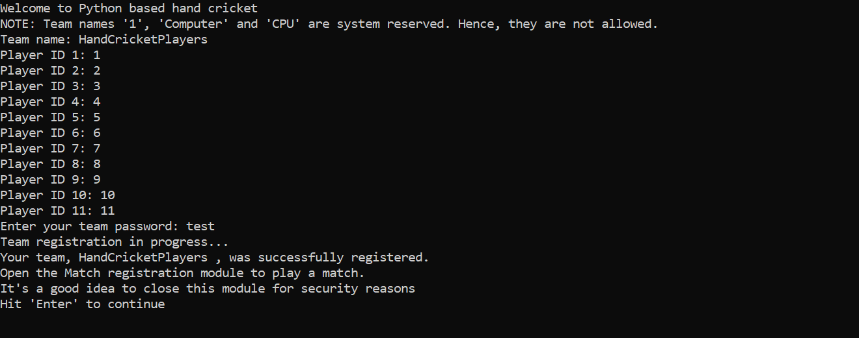

Figure 1: Register team with software: Successful registration message

## Registering for a match

* Once your team is set, you should register for a match before you can play. This is because several teams may exist, and the computer should be able to recognize its opponent.
* For this, open ‘registerformatch.py’.
* This is very simple: Enter your team’s name and your team key.

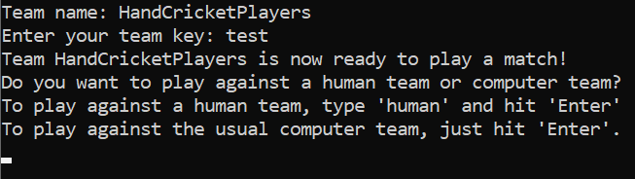

Figure 2: Register a team for a match against the computer: Successful registration message: Now to decide whether you want to play against a team of people or a team of engines. To play against the computer, we simply hit enter without typing anything.

* If you see an option to enter the password, enter a password of your choice and hit ‘Enter’ key or its equivalent(s).

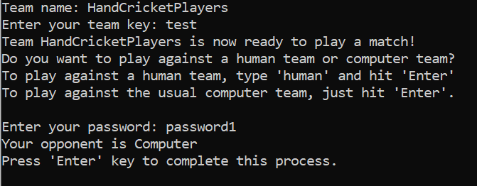

Figure 3: The match is confirmed.

* At this point, the process is completed. You can hit ‘Enter’ and close this module.

## Gameplay

* Now, you are ready to play! Open ‘handcricketgame.py’ to start playing. Your opponent is computer controlled.
* First, you should enter the OTP which you entered while registering for the match.
* Next, you’ll get to choose the number of overs for the match. The default is a 20 over match. Your input should be a positive integer. Otherwise (or if you hit ‘Enter’ without giving any input), the game will last for 20 overs. There is no test match.

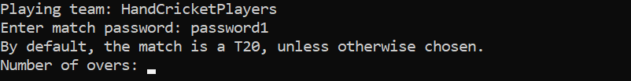

Figure 4: Password verified. In this example, the password chosen was ‘password1'. Now choose the number of overs of the game.

* Now choose the number of wickets for the match. It must be a positive integer from 1 to 10, both included. Otherwise (or if you hit ‘Enter’ without giving any input), the game will last for 10 wickets.

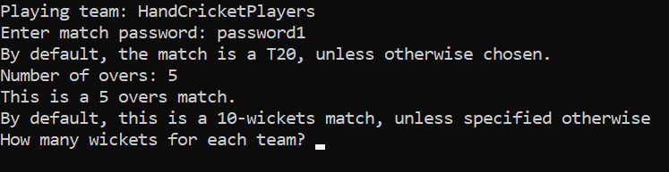

Figure 5: Decided number of overs. For example, this match has 5 overs per innings. Now choose the number of wickets.

* Now it’s time for the toss. Choose a number from 0 to 6. Then choose ‘Odd’ or ‘Even’. Write exactly the same words in the same uppercase/lowercase order. In case of invalid input, you’ll automatically lose the toss. The following exceptions apply for the number chosen:
  + If you choose any other integer, the chosen integer is selected. The only restriction is that the input must be an integer. The 0 to 6 integer range will not be enforced, but it’s recommended.
  + If your choice is not an integer, 0 will be chosen by default.

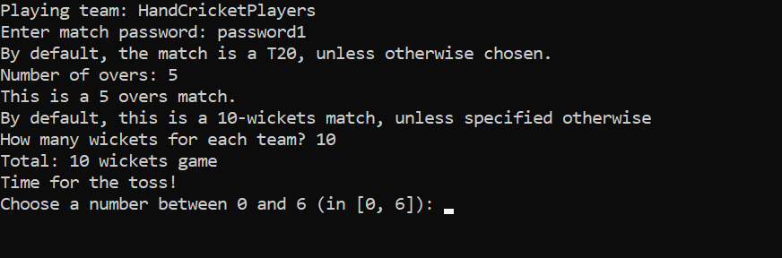

Figure 6: Time for the toss! Follow the instructions. You can choose 0, 1, 2, 3, 4, 5 or 6 as your input.

* If you win the toss, you can choose whether to bat first or field first. Choose wisely. Again, write exactly the same words in the lowercase order only. Any other input, and you will be randomly assigned batting or fielding.

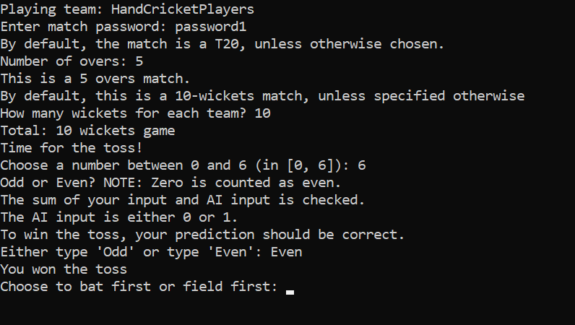

Figure 7: Won the toss. Type the exact word 'bat' or 'field'. If you want to bowl first, type 'field'.

If you’re batting, first choose your batters from the list of available batters. Then, just input the number of runs that you want to score and that will add to your score. But here’s the catch: The number must be an integer between 0 and 6, both included. Your opponent must also input any integer in the same range. Thus, if your number matches with your opponent’s number, you are out. Your opponent’s number is hidden, so choose wisely. Don’t worry, invalid input results in no run.

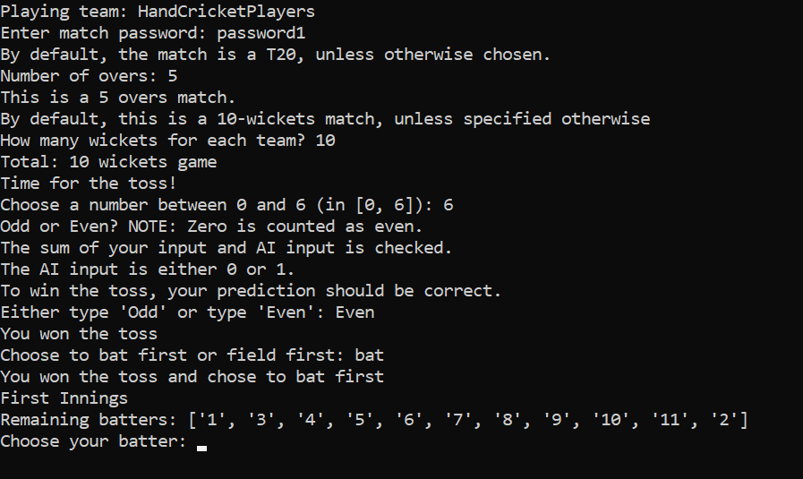

Figure 8: Batting first. Choose your batter

* Note that if your choice of batter/bowler is invalid, a random player from your available list will be selected.

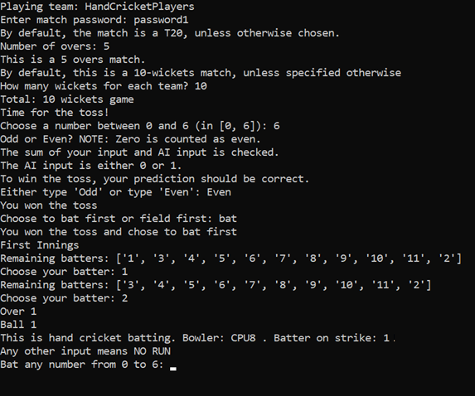

Figure 9: First ball!

* At the end of each over, hit ‘Enter’ or its equivalent(s) to proceed. You can see team score only after any over. At the end of each innings, the innings summary will be displayed.

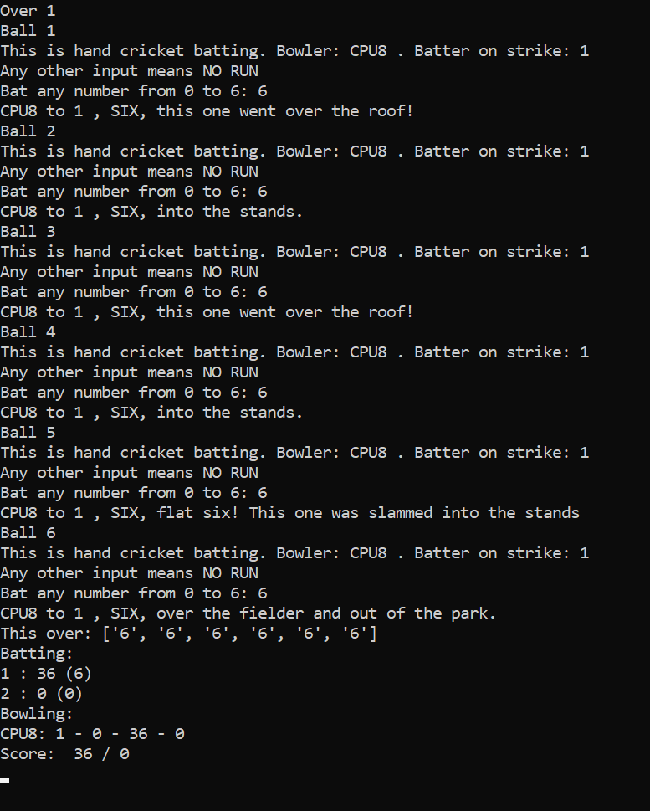

Figure 10: Six sixes in the first over, 36 without loss. Now, hit the ‘Enter’ button to begin the next over. The batters interchange. More action coming up…

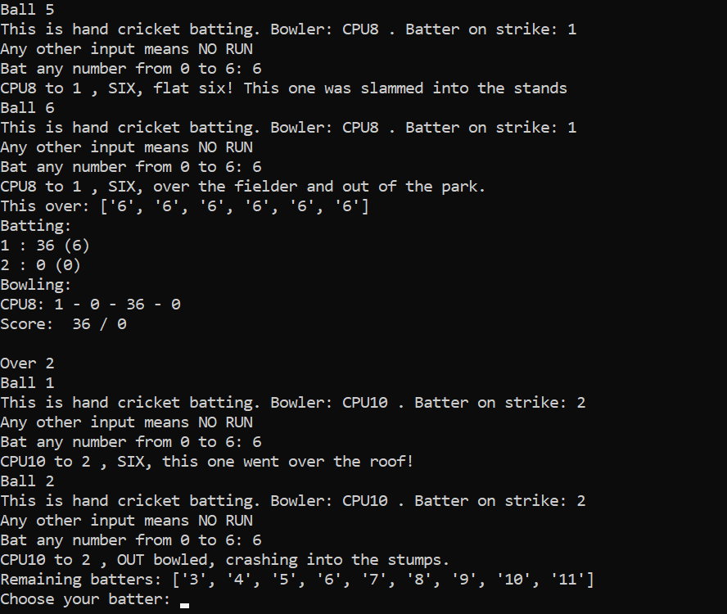

Figure 11: OUT!! The batter attempted to go for the big shot! Instead, he missed the ball and the ball hit the wickets. That's why you may not attempt 6 all the time!

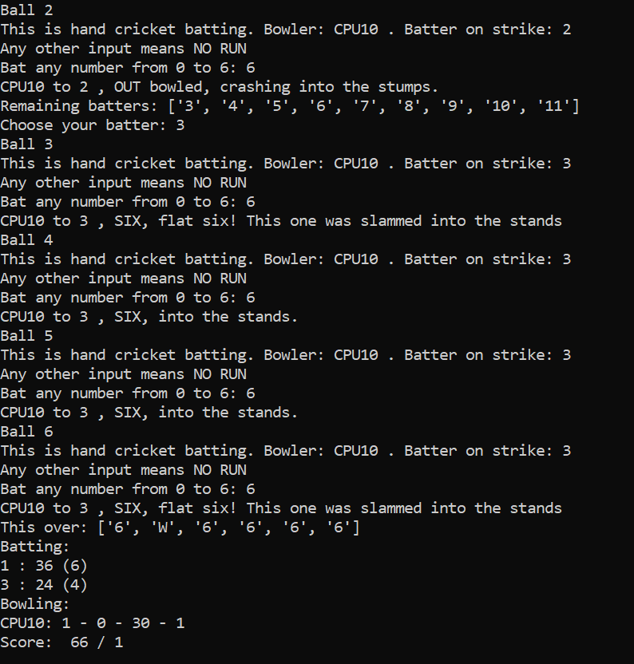

Figure 12: Still going for sixes? Batter number 3 is taking a huge risk! Nevertheless, there are only 5 overs per side, so it may be worth the risk.

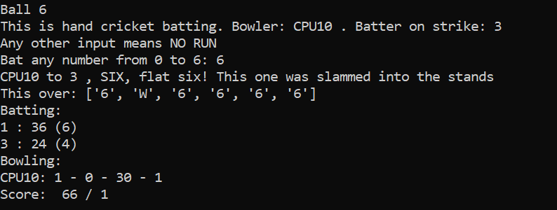

Figure 13: This is what the bowler's figures would look like after the second over of the innings.

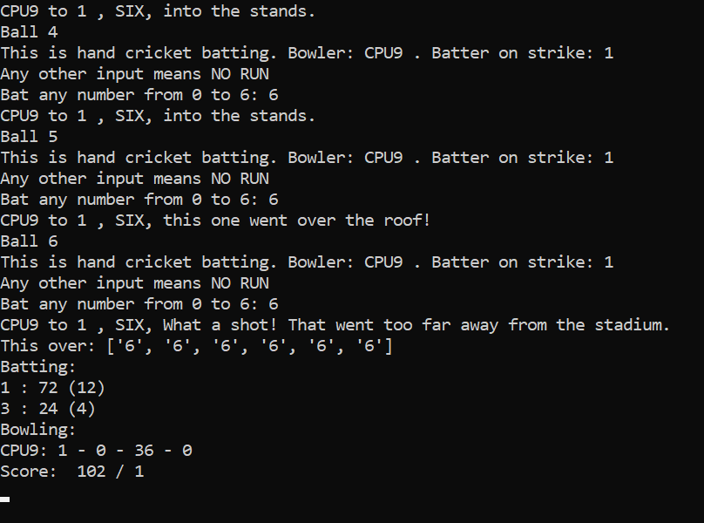

Figure 14: Again, batter 1 hits six sixes in the over. Batter 1 is unstoppable at the moment!

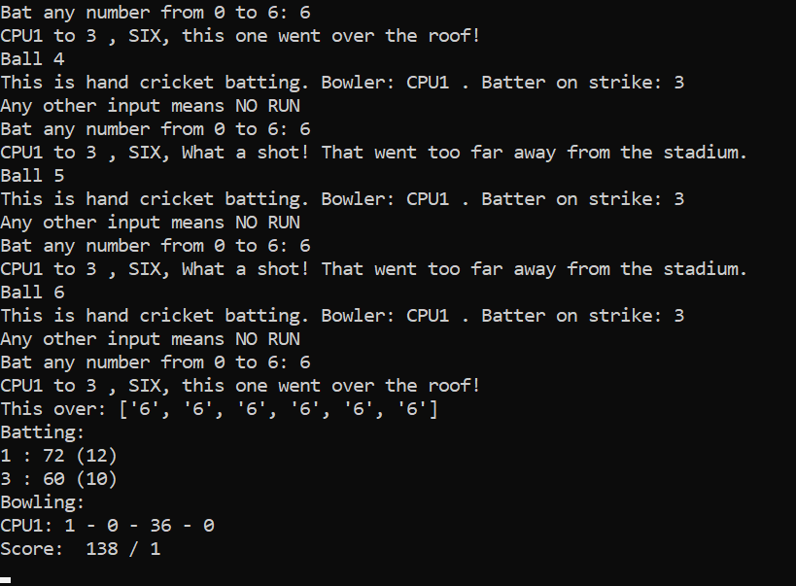

Figure 15: Penultimate over: Nearly perfect batting by this team, except for the loss of a wicket...

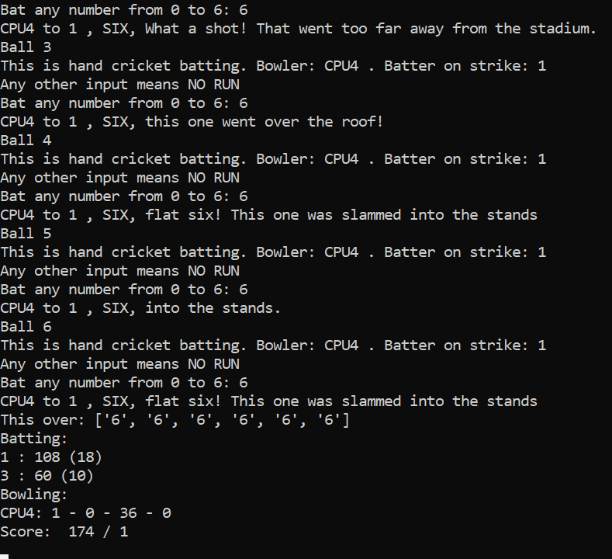

Figure 16: Another perfect over. End of the first innings. Batter 1 has scored a century in just 18 balls, all of them going for sixes! The team scored 174-1 in 5 overs.

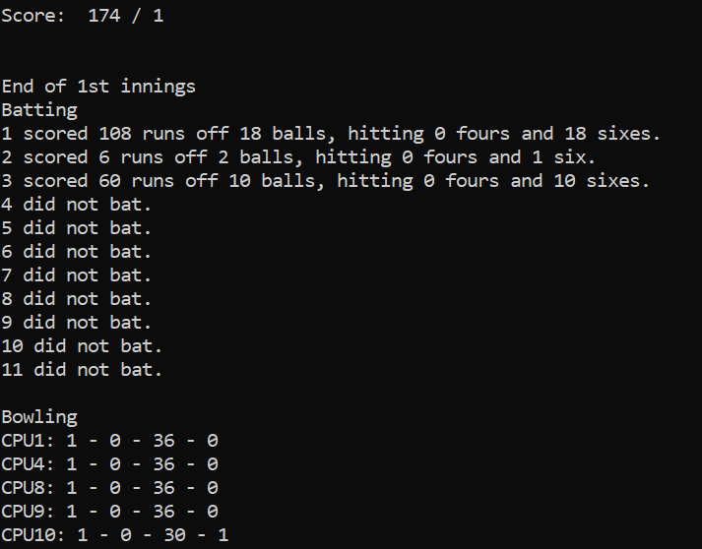

Figure 17: First innings summary. Hit ‘Enter’ key twice to load the summary. This batting scorecard doesn’t show which batter(s) were out, how they were dismissed, and which batter(s) were not.

* Similarly, if you’re bowling (fielding), choose a bowler and input a number in the same range, but you would want your number to match with your opponent’s number to get him out. This time if you give any other integer, your opponent will get a six. If you give any other invalid input, your opponent will score as many runs as its input without getting out. Note that a bowler cannot bowl two consecutive overs and a bowler cannot bowl more than one-fifth of the total number of match overs. For example, in a 20 over game, no bowler is permitted more than 4 overs.

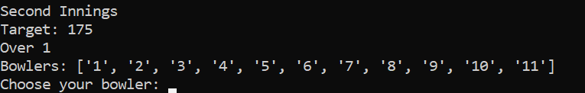

Figure 18: Choose your bowler. The target in this example is 175 runs.

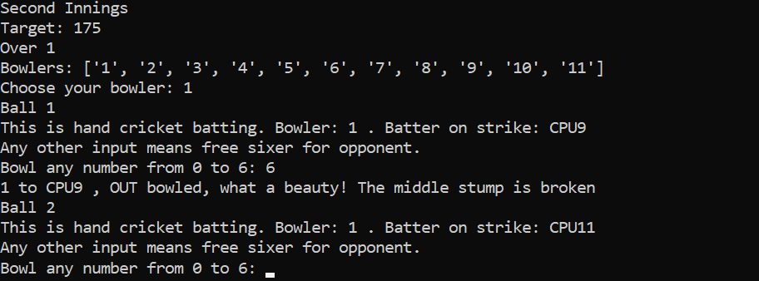

Figure 19: There we go! We claim a wicket in the very first ball of the second innings!

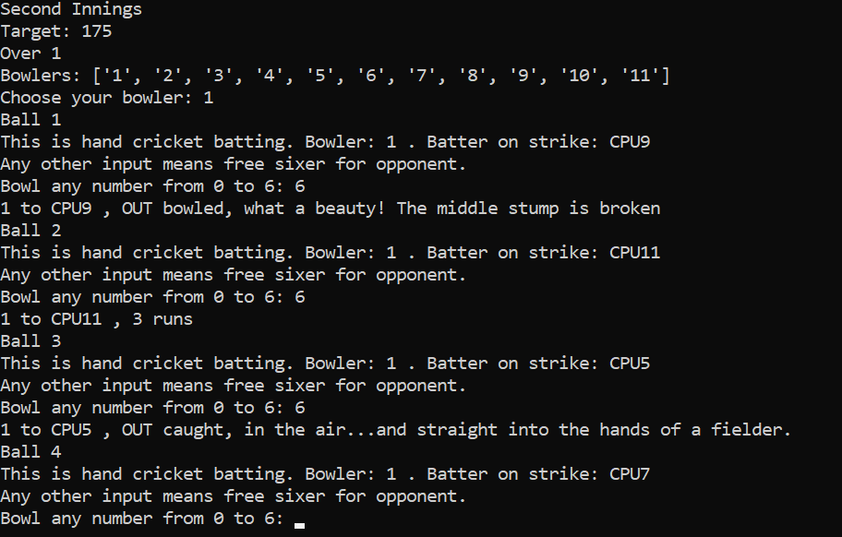

Figure 20: Two wickets in the same over! The opponent requires 172 runs off 27 balls. We have a theoretically won game now, since his required run rate is more than 36 runs per over.

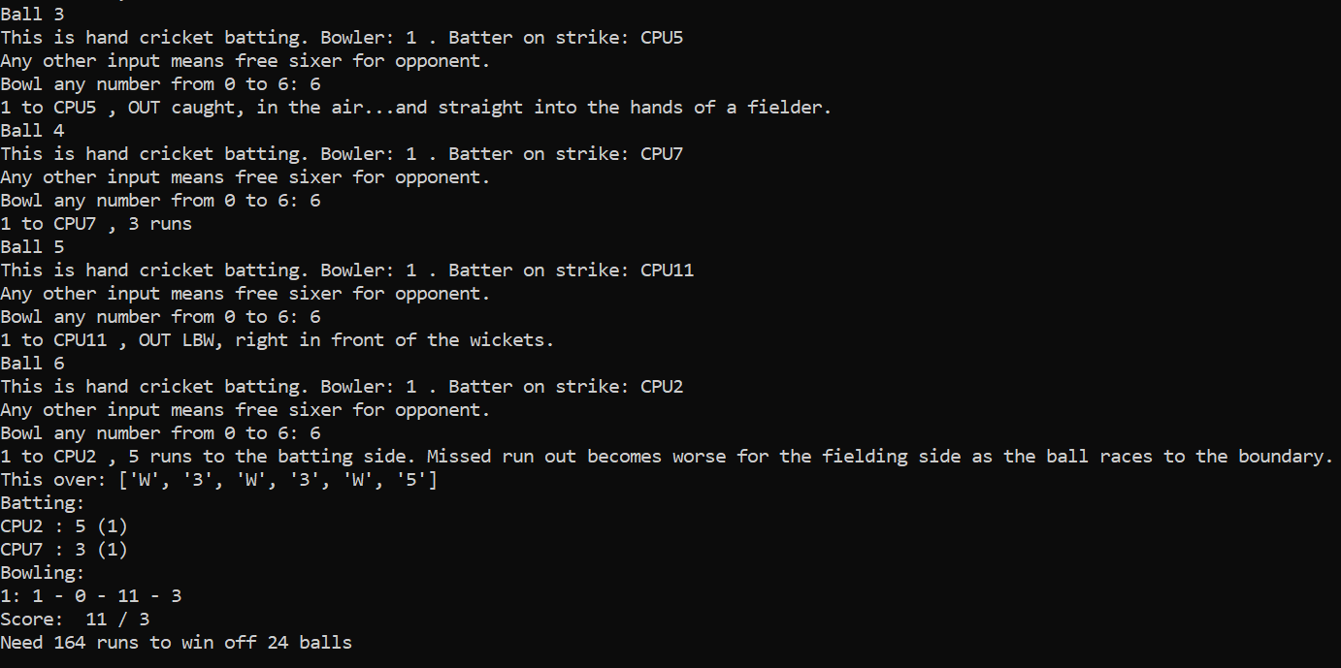

Figure 21: End of the first over, 11-3.

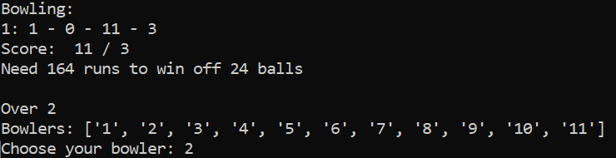

Figure 22: Second over. This list is the list of all bowlers. We can't choose bowler 1 now. Let's pick 2 and see what happens...

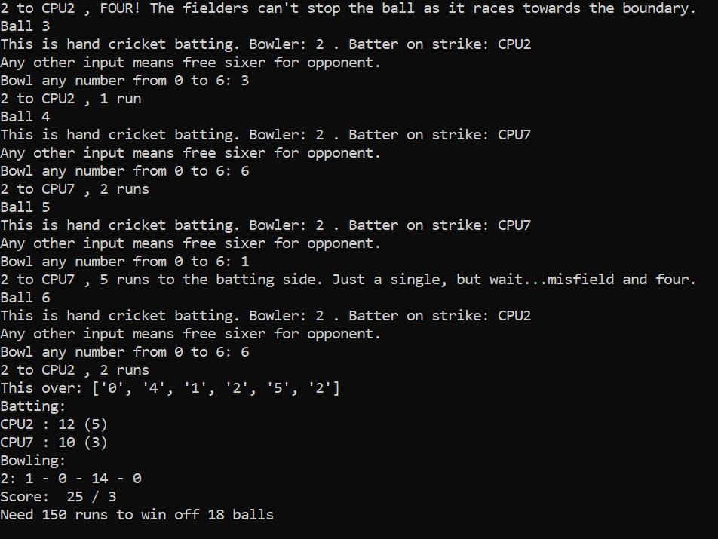

Figure 23: Our bowler in action...

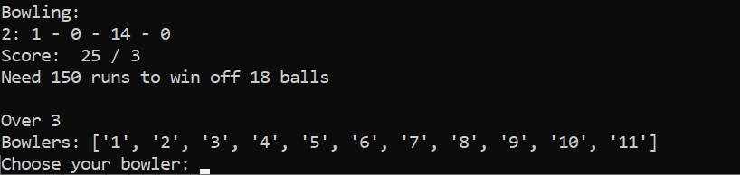

Figure 24: Can't pick bowler 2. Bowler 1 is free, but each bowler has only one over since there are only 5 overs! Let's pick bowler 3.

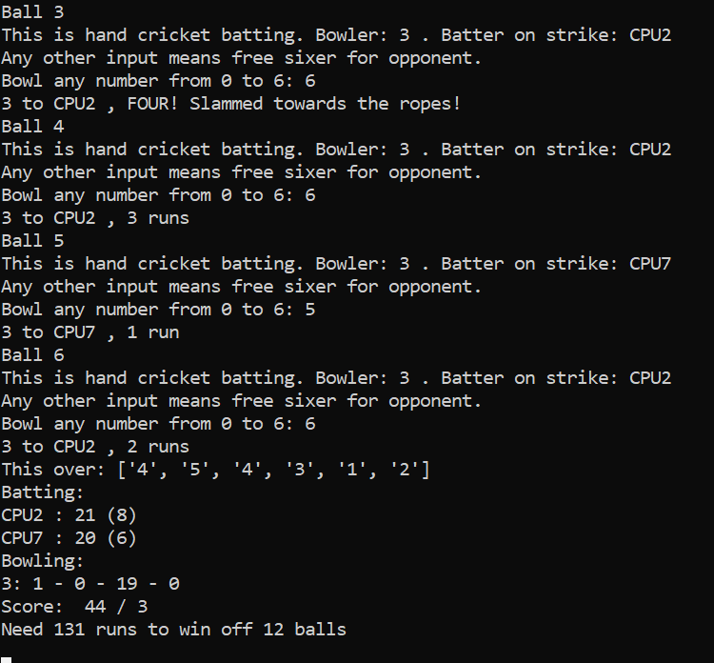

Figure 25: Bowler 3 is having fun!

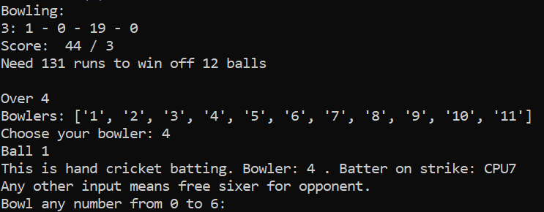

Figure 26: Now let's have fun!!! Bowler 4 will bowl the next over for us.

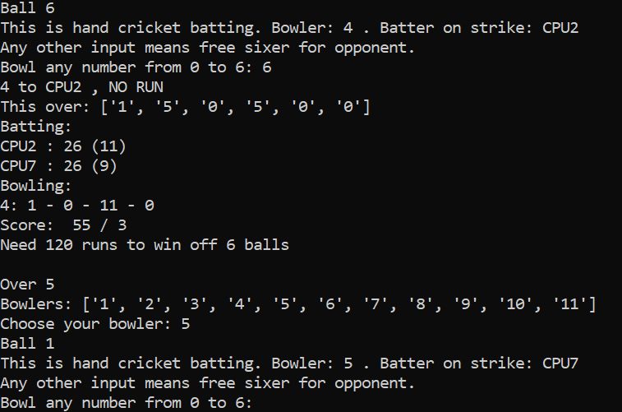

Figure 27: Last over. 120 to win. Impossible! Now it's time to complete this match.

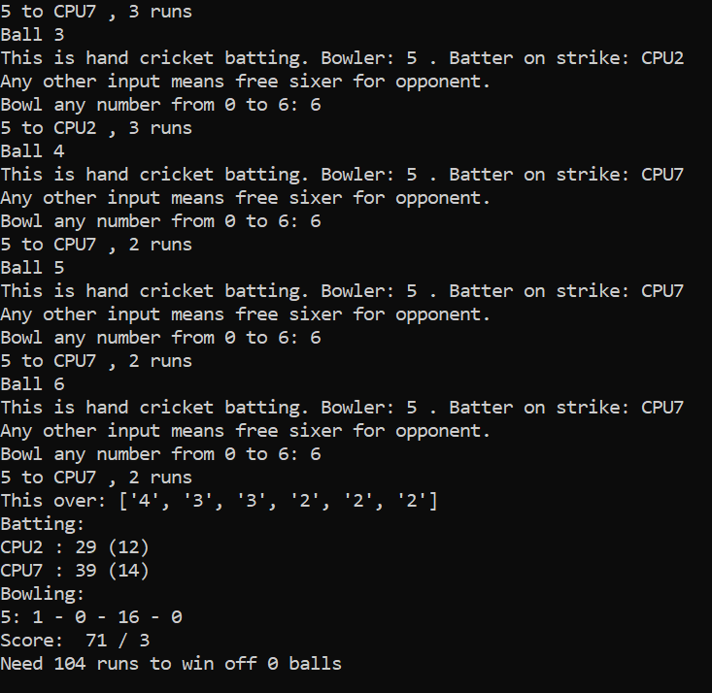

Figure 28: That's it! We win the match.

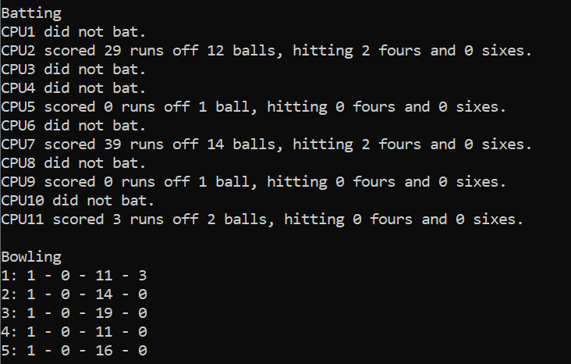

Figure 29: The opponent's batting. We don't have to explicitly declare end of second innings. We win by 103 runs

* Score more than your opponent to win. At the end of the match, the total number of matches that you played and the total number of successful victories will be displayed.

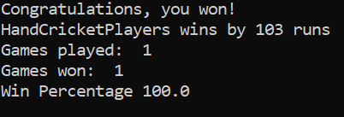

Figure 30: Won the match. This is the winning screenshot.

* In the event of a tie, you have the option of playing super over. Another passcode called the super over key is generated. You will have to keep both match password and super over key safe as you require it to play the super over. If you start another match straightaway without completing the super over, you will be considered to have resigned the match and hence lost. The super over key can be used only once.

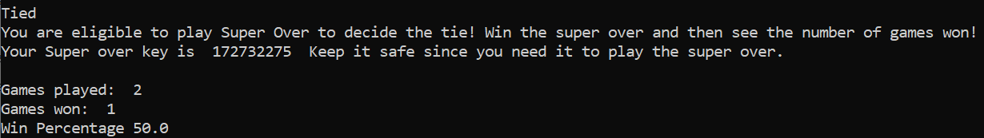

Figure 31: This is what happens if the scores are same. We batted first.

# Super Over

* The super over is the official way to settle ties. The gameplay for super over is as follows:

## Gameplay

* If you have tied your match, open ‘handcricketgamesuperover.py’ to start playing. You will face the same opponent.
* First, you should enter the OTP which you entered while registering for the tied match as well as the super over key.

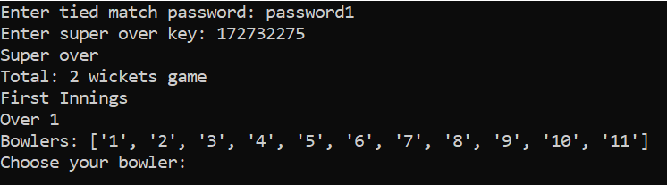

Figure 32: Starting the super over. There is no toss. Since we batted first in the tied match, we bowl first in this super over tiebreaker.

* Each team gets only 1 over and 2 wickets
* There is no toss. If you batted first in the tied match, you will field first in this super over. If you batted second in the tied match, you will bat first in this super over.
* If you’re batting, first choose your batters from the list of available batters. Then, just input the number of runs that you want to score and that will add to your score. But here’s the catch: The number must be an integer between 0 and 6, both included. Your opponent must also input any integer in the same range. Thus, if your number matches with your opponent’s number, you are out. Your opponent’s number is hidden, so choose wisely. Don’t worry, invalid input results in no run.
* Similarly, if you’re bowling (fielding), choose a bowler and input a number in the same range, but you would want your number to match with your opponent’s number to get him out. This time if you give any other integer, your opponent will get a six. If you give any other invalid input, your opponent will score as many runs as its input without getting out. Note that only one bowler is permitted throughout the innings.
* Note that if your choice of batter/bowler is invalid, a random player from your available list will be selected.
* At the end of each over, hit ‘Enter’ or its equivalent(s) to proceed. You can see team score only after any over. At the end of each innings, the innings summary will be displayed.
* Score more than your opponent to win. At the end of the match, the total number of matches that you played and the total number of successful victories will be displayed.
* If you win, the number of games won will be incremented accordingly.
* There is no change to the number of games played, since the super over is only a tiebreaker.

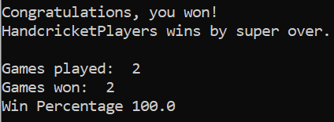

Figure 33: Winning the super over. The tie is broken.

* In the event of a tie, you have the option of playing super over again. Another super over key is generated. You will have to keep the original match password and the new super over key safe as you require it to play the super over. If you start another match straightaway without completing the super over, you will be considered to have resigned the match and hence lost. The super over key can be used only once.

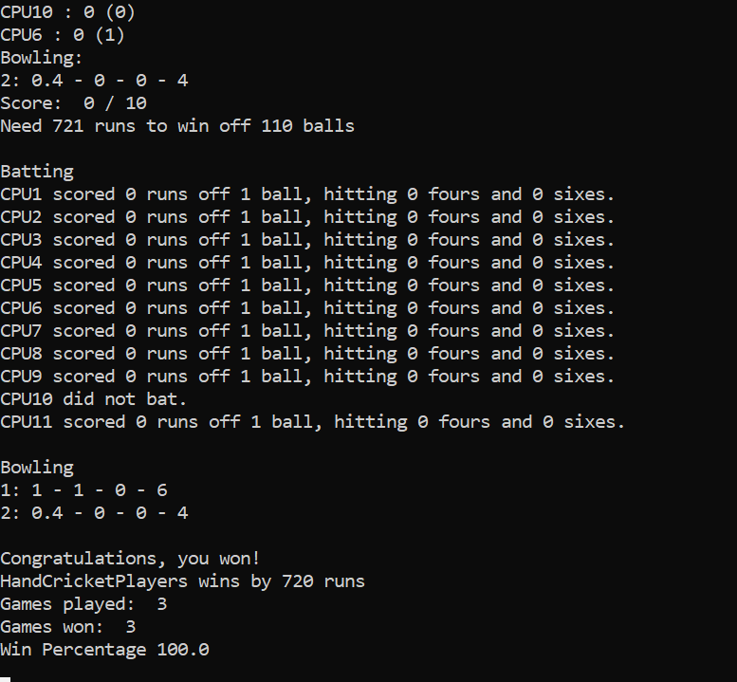

Figure 34: A perfect T20 match. Extremely rare finish!

# Contact Developer:

This Hand Cricket game is developed by Burra Abhishek and licensed under the Terms of the MIT License.

Contact: +91 9884043460

E-Mail: [burra.abhishek1@gmail.com](mailto:burra.abhishek1@gmail.com)

GitHub: <https://github.com/BurraAbhishek>